

Name___________________________________. Mark= /48

|  |  |  |
| --- | --- | --- |
| Test part | Possible mark | Your mark |
| Multiple choice | 10 |  |
| Short answer | 38 |  |
| Total | 48 |  |

HUMAN BIOLOGICAL SCIENCE. YEAR 12. 2016.

Endocrine System Topic Test.

***Multiple choice answer sheet.***

**Use a ball point or ink pen to mark an X** on the letter that represents the best answer from the choice of answers . Marks are not deducted for wrong answers.

|  |  |
| --- | --- |
| Question | Answer |
| 1 | A B C D |
| 2 | A B C D |
| 3 | A B C D |
| 4 | A B C D |
| 5 | A B C D |
| 6 | A B C D |
| 7 | A B C D |
| 8 | A B C D |
| 9 | A B C D |
| 10 | A B C D |

**Multiple Choice**

1. An endocrine gland?
2. Secretes hormones into a duct.
3. Secrete hormones into the lymphatic system.
4. Simulates nerve fibres.
5. Secretes hormones into extracellular fluid.
6. The hormone adrenaline is made in which of the following structures?
7. Adrenal Medulla
8. Adrenal Cortex
9. Hypothalamus gland.
10. Islets of Langerhans.
11. Hormones are transported around the body via?
12. Specialised nerve cells in the infundibulum.
13. Blood vessels of the circulatory system.
14. Blind ended vessels of the lymphatic system.
15. Specialised duct of the endocrine system.
16. Which of the following statements about calcitonin is correct?
17. It is produced in the thyroid gland and helps balance the amount of calcium in the blood.
18. It is produced in the parathyroid gland and helps balance the amount of calcium in the blood.
19. It is produced in the hypothalamus and increases the calcium deposition in the bones.
20. It is produced in the hypothalamus and helps add calcium to your teeth.
21. The corpus luteum can be described as which of the following?
22. A temporary exocrine gland producing follicle stimulating hormone.
23. A temporary endocrine gland producing follicle stimulating hormone
24. A temporary exocrine gland producing oestrogen only.
25. A temporary endocrine gland producing oestrogen and progesterone.
26. Cushing’s Syndrome is a hormonal disorder caused by high levels of cortisol in the blood. This could be caused by which of the following?
27. Dysfunction of the pituitary gland.
28. Dysfunction of the Islets of Langerhans.
29. Dysfunction of the testes.
30. Dysfunction of the ovaries.

7. Oxytocin:

A. allows milk secretion or "milk let-down"  
B. starts milk production in the mammary glands  
C. is produced by cells in the thyroid  
D. exerts important effects on metabolic rate

1. What is the ultimate function of hormones?
2. Maintain homeostasis.
3. Stimulate growth.
4. Stimulate metabolism.
5. Maintain adults in a state allowing reproduction to take place.
6. Which of the following functions both as an endocrine gland and an exocrine gland?
7. The pituitary
8. The adrenal medulla
9. The adrenal cortex
10. The pancreas.
11. Oxytocin and Anti-diuretic hormone are produced by:
    1. the posterior pituitary.
    2. the anterior pituitary.
    3. the hypothalamus.
    4. the pancreas.

**Short Answer Questions**

1. Use the diagram below to answer the following questions.

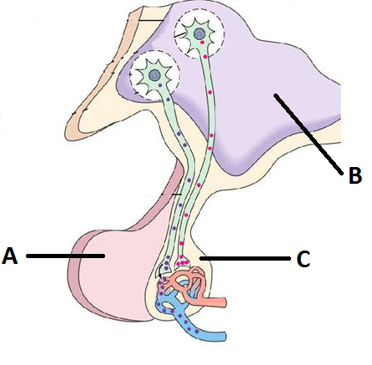

1. Identify the structures A, B and C. (3 marks)

|  |  |
| --- | --- |
| Structure | Name |
| A |  |
| B |  |
| C |  |

1. Identify 2 hormones released by structure A, identify the target organ/cells and describe the effects. *(6 marks)*

|  |  |  |
| --- | --- | --- |
| Hormone | Target Cell | Main Effects |
|  |  |  |
|  |  |  |

1. Describe how the hypothalamus communicates with the anterior and posterior pituitary. *(4 marks)*

_______________________________________________________________________________________________________________________________________________________________________________________________________________________________________________________________________________________________________________

_________________________________________________________________________________________________________________________________________________________________________________________________________________________________________________________________________________________________________________________________________________________________________________________________________________________________________________________________________________________________________________________

__________________________________________________________________________________________________________________________________________________________________________________________________________

1. Describe the processes leading to the secretion of hormones from the anterior lobe into the blood stream. *(3 marks)*

______________________________________________________________________________________________________________________________________________________________________________________________________________________________________________________________________________________________________________________________________________________________________________________________________________________________________________________________________________________________________________________________________________________________________________________________________________________________

1. Explain why the posterior lobe is **not** considered to be a true endocrine gland. *(2 marks)*

_______________________________________________________________________________________________________________________________________________________________________________________________________________________________________________________________________________________________________________

_____________________________________________________________________________________________________

1. Complete the following table regarding endocrine glands: *(20 marks)*

|  |  |  |  |  |
| --- | --- | --- | --- | --- |
| Gland | | Hormone produced | Target cells | Main effects |
| Thyroid | |  |  |  |
| Parathyroid | |  | Bones and kidneys |  |
|  | | Corticosteroids such as:  Aldosterone  Glucocorticoids  Such as :  Cortisol |  |  |
|  | |  | Most cells but primarily cardiac/circulatory | They bring about the sympathetic response.  ________________ increases heart rate  ____________________ increases blood  pressure. |
| Pancreas | Beta cells |  | Liver and muscles |  |
| Alpha  cells |  | Liver and muscles |  |
| Gonads | Testes | Androgens |  |  |
| Ovaries | Oestrogen  ___________________ | Many tissues  Uterus and Mammary glands |  |